HCA ETL-SOFTWARE INSTALLATION

First configure HCA outlook mail and webex communicator.
Click on below link to check outlook web:
https://outlook.office365.com/owa/hca.corpad.net/

Click on below link to check jira access:
https://jira.app.medcity.net/j/browse/CES-16969

Click on below to check Service now access:
https://hcaservicecentral.service-now.com/hca/

Click on below link to check Confluence access:
https://confluence.app.medcity.net/c/display/CES/ER+Wait+Times+-+Disable+a+facility

Migration path:
Copy below path and paste in file explorer to check access for Migration
file://corpdpt02/dfs/CERTIFICATION/APPLICATION%20BUILDS/STAGE/DMXPRESS/CL

Click on below link to check access for sharepoint:
https://teamrooms.hca.corpad.net/sites/Ent_Data_Arch/Docs/HR/_layouts/15/start.aspx#/Shared%20Documents/Forms/AllItems.aspx

Dmx Installation Process:
\\corpdpt02\DFS\DMExpress\DMExpressInstall
Open above path and copy ConnectETL9.11 folder to local and refer below document to install

WINSCP:
Copy below path to local and open winscp556setup.exe
\\corpdpt02\DFS\UC_implementation\UC Team Stuff\Software

PUTTY:
\\corpdpt02\DFS\UC_implementation\UC Team Stuff\Software
Open below path and copy putty.exe to local and double click
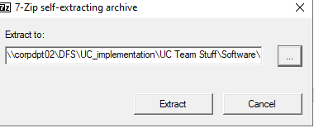
Click on browse
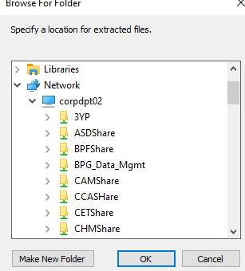
Click on make new folder and create folder and extract
Open folder and create shortcut of putty.exe
Open putty.exe and below window will appear type host name and click open
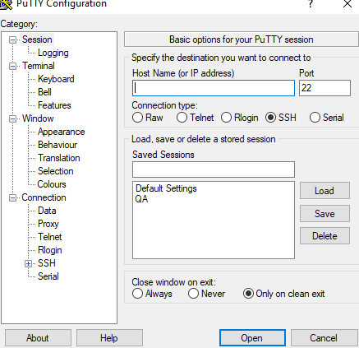

Zeke –
Open below path and copy TN3270 Folder to local and install Tn3270.exe
\\Corpdpt02\dfs\Supply Chain Ops - Financial Mgmt\Initial Setup\TN3270
Login process:
You will get temp password from CORP.IAccess@HCAHealthcare.com if not, mail to them to get temp password
Open zeke below window will display
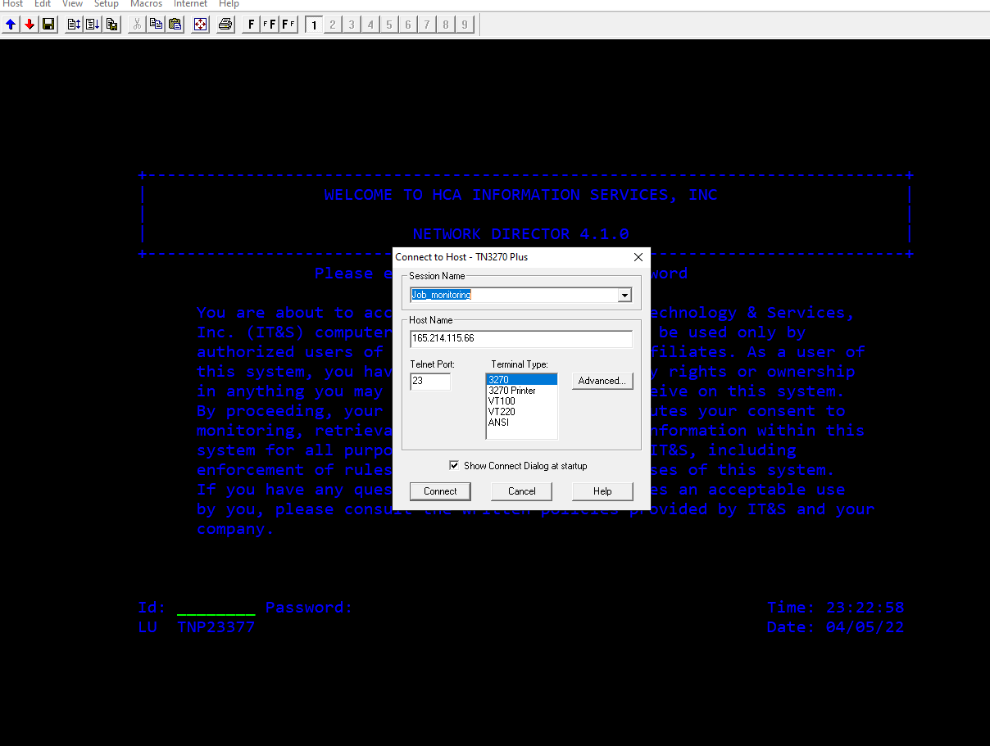
Click on connect and enter ur 3-4 id and new password
After below window will display
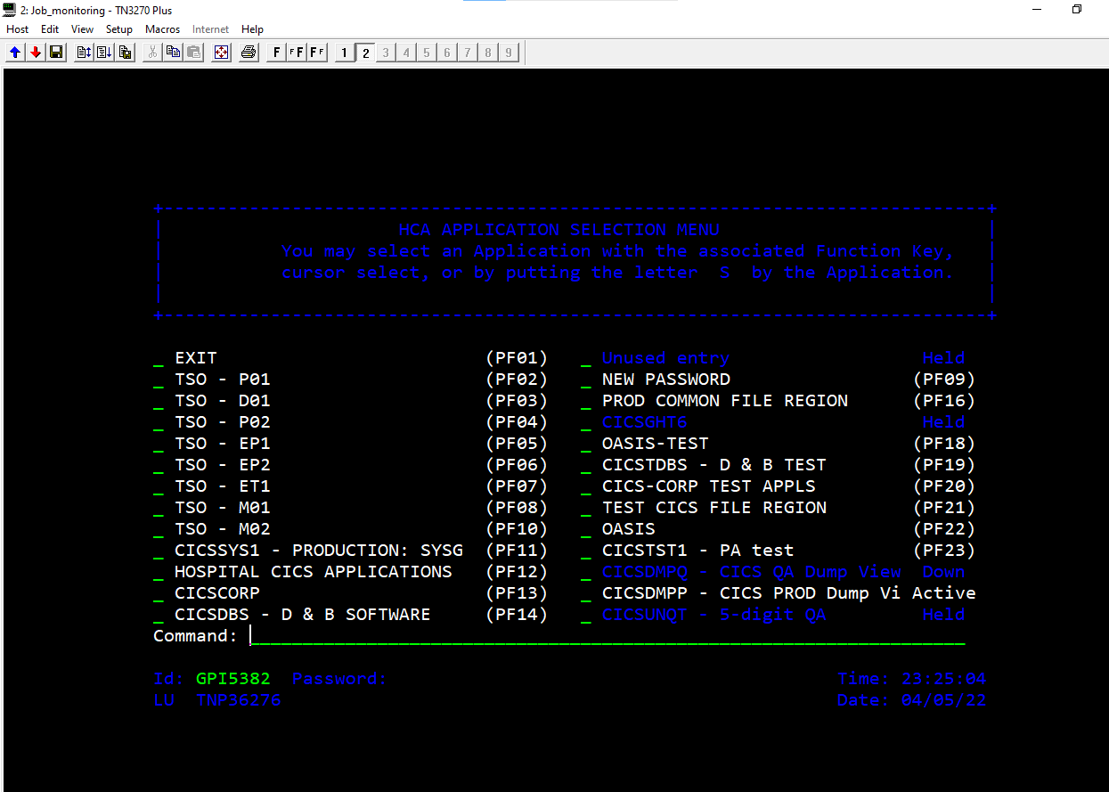
Now press f3 and hit enter
The below window will display
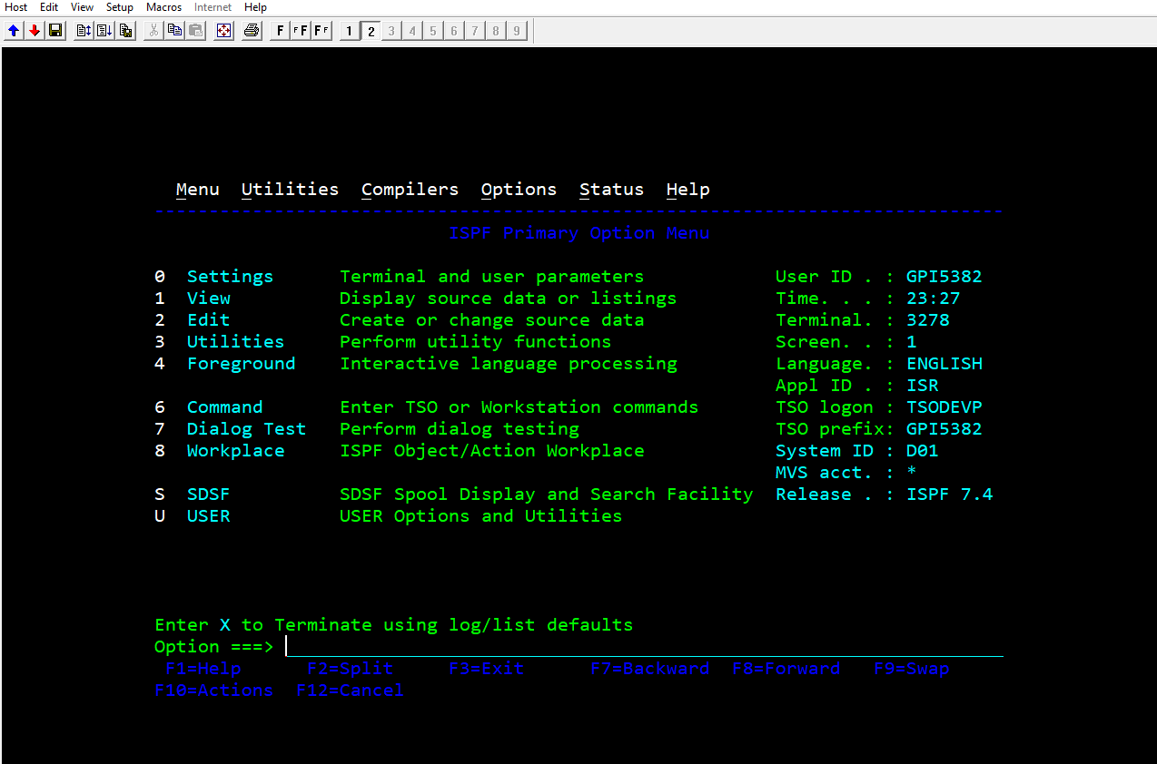
Now in option give u;12;ze;2
The below window will display
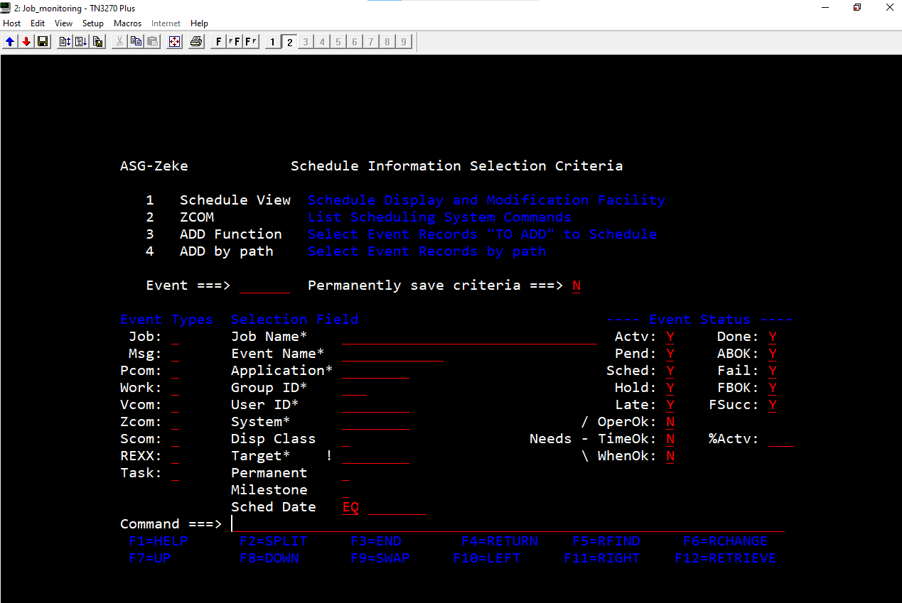
In the Zeke Scheduler View we can find any job by typing the job name as shown above

TERADATA:
Install below two Teradata softwares from software centre for Teradata

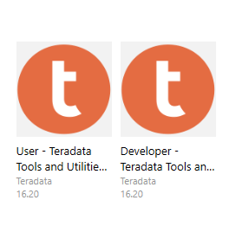

To check access of tera data open Teradata sql assistant and click on connect symbol
It will navigate to this page and then click on Machine data source and then check access for QA,PROD Environments.
